Online Payments Fraud Detection using Machine Learning

Project Description:
Online Payments Fraud Detection using Machine Learning is a proactive approach to identify and prevent fraudulent activities during online transactions. By leveraging historical transaction data, customer behavior patterns, and machine learning algorithms, this project aims to detect potential fraud in real time, ensuring secure and trustworthy online payment experiences for users and businesses alike.
The system continuously monitors online payment transactions in real time. By analyzing transaction features such as transaction amount, location, device information, and user behavior, it can flag suspicious transactions for further investigation, preventing fraudulent activities before they occur.
Machine learning models can detect patterns indicative of fraudulent accounts or activities. By analyzing user behavior over time, such as unusual login times, multiple failed login attempts, or sudden changes in spending patterns, the system can identify and block potentially fraudulent accounts, protecting legitimate users and businesses.
The system adapts and improves its fraud detection capabilities over time. By continuously learning from new data and adjusting its algorithms, it can stay ahead of evolving fraud techniques and trends, providing ongoing protection against online payment fraud for businesses and their customers.
Technical Architecture:
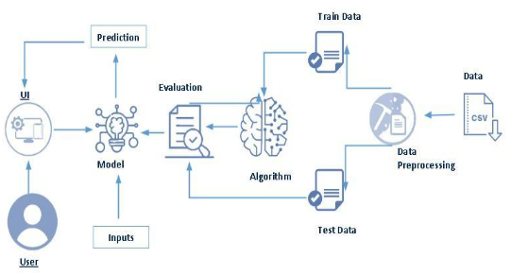

Pre-Requisites:
To complete this project, the following software and packages are required:

Anaconda Navigator is an open-source software distribution used for package management and deployment of Python applications.
Python Packages:

Open anaconda prompt as administrator

Type “pip install numpy” and click enter.

Type “pip install pandas” and click enter.

Type “pip install scikit-learn” and click enter.

Type ”pip install matplotlib” and click enter.

Type ”pip install scipy” and click enter.

Type ”pip install pickle-mixin” and click enter.

Type ”pip install seaborn” and click enter.

Type “pip install Flask” and click enter.

Prior Knowledge :
You must have prior knowledge of following topics to complete this project.

ML Concepts
    - Supervised learning:
https://www.javatpoint.com/supervised-machine-learning
    - Unsupervised learning:
https://www.javatpoint.com/unsupervised-machine-learning
    - Regression and classification
    - Decision tree:
https://www.javatpoint.com/machine-learning-decision-tree-classification-algorithm
    - Random forest:
https://www.javatpoint.com/machine-learning-random-forest-algorithm
    - KNN:
https://www.javatpoint.com/k-nearest-neighbor-algorithm-for- machine-learning
    - Xgboost:
https://www.analyticsvidhya.com/blog/2018/09/an-end-to-end-guide-to-understand-the-math-behind-xgboost/
    - Evaluation metrics:
https://www.analyticsvidhya.com/blog/2019/08/11- important-model-evaluation-error-metrics/
  - Flask Basics : https://www.youtube.com/watch?v=lj4I_CvBnt0

Project Objectives:
By the end of this project you will:
- Understand Machine Learning prediction concepts
- Gain knowledge about wind energy datasets
- Learn data preprocessing techniques
- Understand relationship between wind parameters and power generation
- Learn how to build prediction models

Project Flow:
- User provides input dataset
- Dataset is analyzed
- Model is trained using historical wind data
- Model predicts the wind power generation

To accomplish this, we have to complete all the activities listed below,
- Data collection
- Collect the dataset or create the dataset
- Visualizing and analyzing data
- Univariate analysis
- Bivariate analysis
- Multivariate analysis
- Descriptive analysis
- Data pre-processing
- Checking for null values
- Handling outlier
- Handling categorical data
- Splitting data into train and test
- Model building
- Import the model building libraries
- Initializing the model
- Training and testing the model
- Evaluating performance of model
- Save the model
- Application Building
- Create an HTML file
- Build python code

Project Structure:
Create the Project folder which contains files as shown below
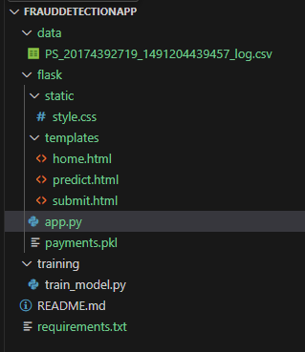

  - The templates folder contains all the HTML files such as home.html, predict.html and submit.html which are used to build the user interface of the Wind Energy Prediction web application.
  - The Training folder includes the dataset file (dataset.csv) and the Python script (train_model.py) which are used for data preprocessing, training and testing the Machine Learning model.
  - The payments.pkl file stores the trained Machine Learning model which is used by the application to predict wind power output based on user input parameters.
  - The app.py file acts as the backend of the Flask application which connects the user interface with the trained model and displays the prediction results.

Milestone 1: Data Collection
Machine Learning depends heavily on data. Dataset can be downloaded from open-source platforms or created manually.
Link:
https://www.kaggle.com/datasets/rupakroy/online-payments-fraud-detection-dataset
Milestone 2: Visualizing and Analyzing the Data

Activity 1: Importing Libraries
Required libraries such as NumPy, Pandas and Matplotlib are imported for dataset
analysis. 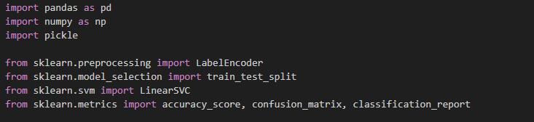

Activity 2: Reading the Dataset
Dataset is read using pandas from CSV, Excel or Text files.

Activity 3: Dataset Analysis
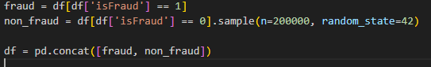
Dataset is analyzed to understand:
Wind speed variation Wind direction Power generation
Relationship between wind parameters and generated power is identified using visualization techniques.

Milestone 3: Data Pre-processing
Collected dataset is cleaned before training the model.
Steps involved:
Handling Missing Values Handling Categorical Data Normalization
Feature Selection Splitting Dataset

Activity 1: Checking for Null Values
Dataset shape and data types are checked using: df.shape df.info() df.isnull().sum()
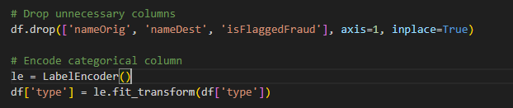

Activity 2: Handling Categorical Values
Categorical values are converted into numerical format for model training.
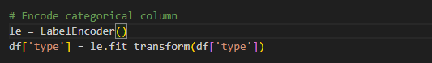

Activity 3: Splitting Dataset
Datasetis split into:
Independent Variables (X) Dependent Variable (Y)
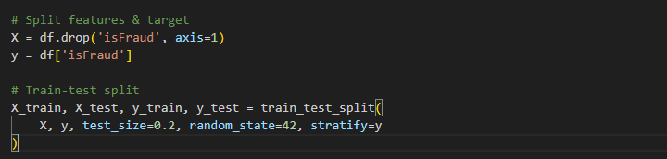
Training and Testing datasets are created:
80% Training Data
20% Testing Data

Milestone 4: Model Building
Now our data is cleaned and it’s time to build the model. We can train our data on different algorithms. for this project we are applying four classification algorithms. The best model is saved based on its performance.
Activity 1: Decision tree model
A function named decisionTree is created and train and test data are passed as the parameters. Inside the function, DecisionTreeClassifier algorithm is initialized and training data is passed to the model with .fit() function. Test data is predicted with .predict() function and saved in new variable. For evaluating the model, confusion matrix and classification report is done.
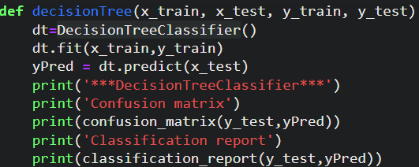
Activity 2: Random forest model
A function named randomForest is created and train and test data are passed as the parameters. Inside the function, RandomForestClassifier algorithm is initialized and training data is passed to the model with .fit() function. Test data is predicted with .predict() function and saved in new variable. For evaluating the model, confusion matrix and classification report is done.
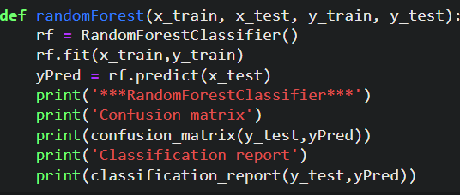
Activity 3: KNN model
A function named KNN is created and train and test data are passed as the parameters. Inside the function, KNeighborsClassifier algorithm is initialized and training data is passed to the model with .fit() function. Test data is predicted with .predict() function and saved in new variable. For evaluating the model, confusion matrix and classification report is done.
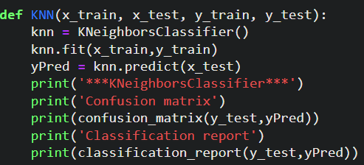
Activity 4: Xgboost model
A function named xgboost is created and train and test data are passed as the parameters. Inside the function, GradientBoostingClassifier algorithm is initialized and training data is passed to the model with .fit() function. Test data is predicted with .predict() function and saved in new variable. For evaluating the model, confusion matrix and classification report is done.
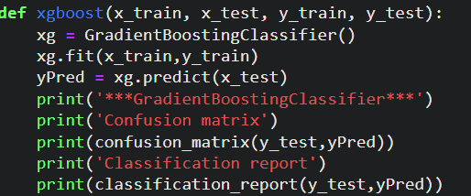
Now let’s see the performance of all the models and save the best model

Activity 5: Compare the model
For comparing the above four models compareModel function is defined.
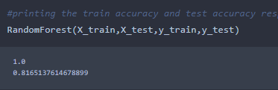
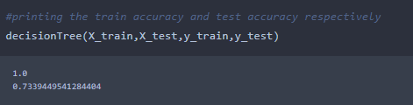
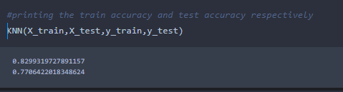
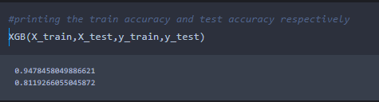
After calling the function, the results of models are displayed as output. From the four model Xgboost is performing well. From the below image, We can see the accuracy of the model. Xgboost is giving the accuracy of 94.7% with training data , 81.1% accuracy for the testing data.so we considering xgboost and deploying this model.

Milestone 5: Application Building
In this section, we will be building a web application that is integrated to the model we built. A UI is provided for the uses where he has to enter the values for predictions. The enter values are given to the saved model and prediction is showcased on the UI.
This section has the following tasks
- Building HTML Pages
- Building serverside script
Activity1: Building Html Pages:
For this project create three HTML files namely
- home.html
- predict.html
- submit.html
and save them in templates folder.
Let’s see how our home.html page looks like:
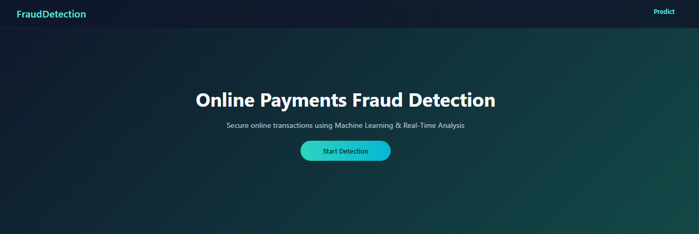
Now when you click on predict button from top right corner you will get redirected to predict.html
Lets look how our predict.html file looks like:
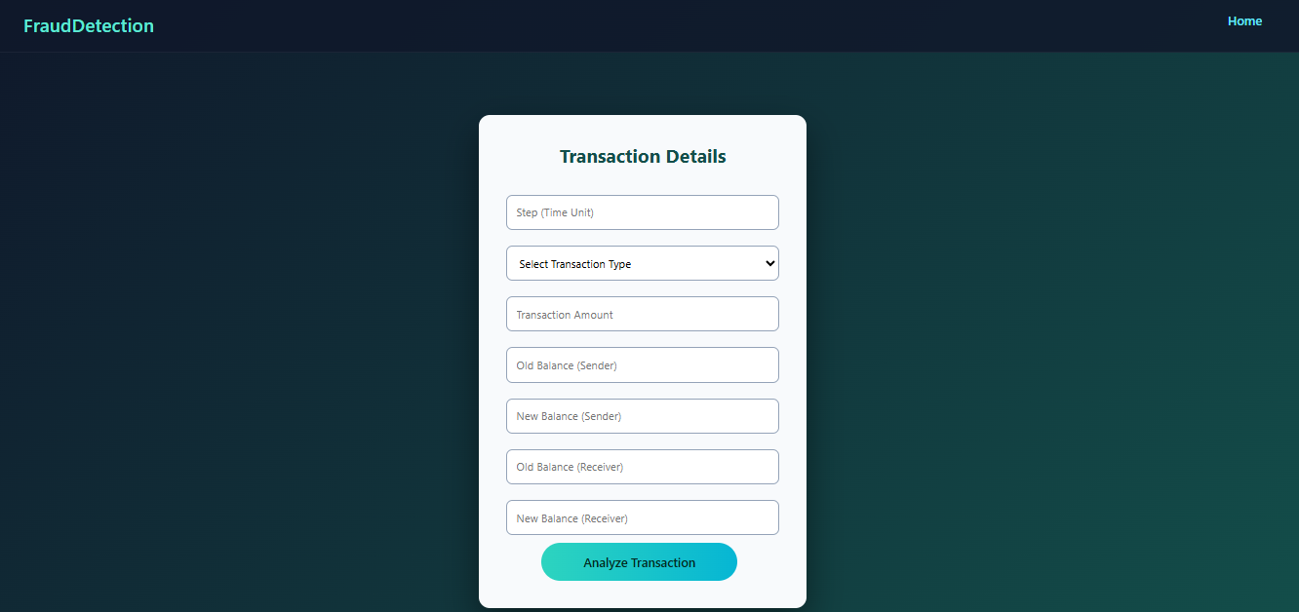
Now when you click on predict button from left bottom corner you will get the prediction of the energy
Lets look how our file looks like:
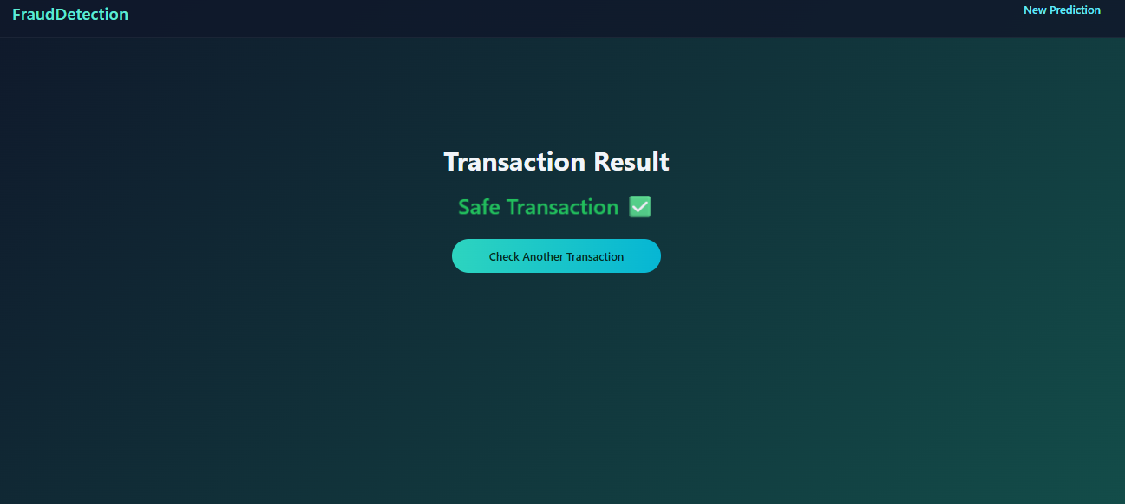
Activity 2: Build Python code:
Import the libraries
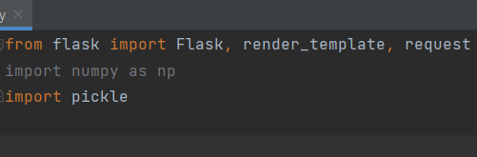
Load the saved model. Importing flask module in the project is mandatory. An object of Flask class is our WSGI application. Flask constructor takes the name of the current module (__name__) as argument.
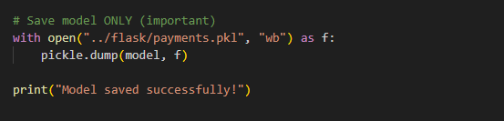
Render HTML page:
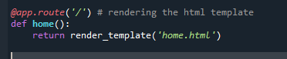
Here we will be using declared constructor to route to the HTML page which we have created earlier.
In the above example, ‘/’ URL is bound with home.html function. Hence, when the home page of the web server is opened in browser, the html page will be rendered. Whenever you enter the values from the html page the values can be retrieved using POST Method.
Retrieves the value from UI:
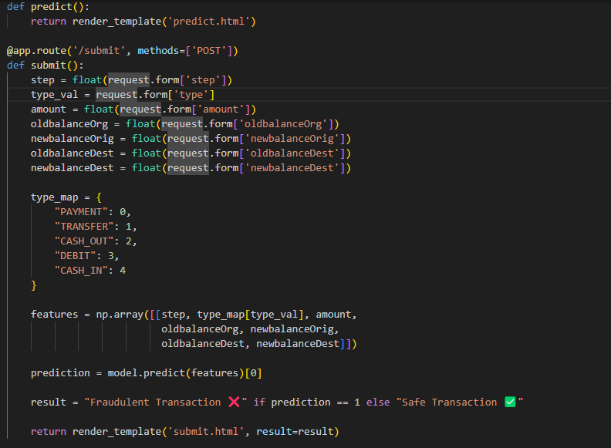

Here we are routing our app to predict() function. This function retrieves all the values from the HTML page using Post request. That is stored in an array. This array is passed to the model.predict() function. This function returns the prediction. And this prediction value will rendered to the text that we have mentioned in the submit.html page earlier.
Main Function:
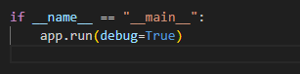
Activity 3: Run the application
- Open anaconda prompt from the start menu
- Navigate to the folder where your python script is.
- Now type “python app.py” command
- Navigate to the localhost where you can view your web page.
- Click on the predict button from top left corner, enter the inputs, click on the submit button, and see the result/prediction on the web.

